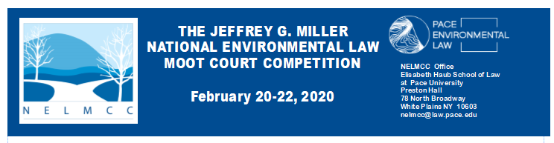

Due October 24, 2019 – Team Confirmation Form

The Team Member Confirmation lists individual team members from competing schools. Even if you have previously provided the information during registration, please complete the form by October 24, 2019. If there is a change on the coach/advisor portion after submission to the NELMCC office, notify us at nelmcc@law.pace.edu.

School Name:

Team Number:

Please check for special dietary needs

Name of Each Team Member E-mail Address Vegetarian Vegan Allergy
1)
2)
3)

Accompanying Team
Name of Coach(es)/Advisor(s) E-mail Address to Oral Arguments
1) |  | Yes □ No □
2) |  | Yes □ No □
3) |  | Yes □ No □

Please indicate special dietary needs for any of the coaches who are attending the oral arguments in February.

SEND BY E-MAIL

Lorraine Rubich, Preston 212
NELMCC Office
Elisabeth Haub School of Law at Pace University
78 North Broadway
White Plains, NY 10603
Tel: 914-422-4413
E-mail: nelmcc@law.pace.edu

